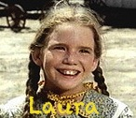

See it!

See it!

See it!

Visit [www.lhp.yolasite.com](http://www.lhp.yolasite.com)

The Official Website of the Little House on the Prairie Fan Club